Power BI
Supermarket Dataset Description:
This dataset contains 9,800 supermarket sales records.
Each row represents one product sold in an order.
The data includes:
- Order information: Order ID, order date, shipping date, ship mode
- Customer information: Customer name, segment, city, state, region
- Product information: Product category, sub-category, product name
- Sales amount: How much money was made from the product

ETL steps:
- Extraction
Extract data from the Excel file to the Power Query Editor in Power BI.
- Transformation
Applied several steps to clean and prepare the dataset for analysis, including:
  - Identify the data types in each column
  - Correct the Order Date and Ship Date because they are in incorrect formats.
1. Split column to days ,months ,years
2. Merge columns month/day/year in one column

  - We checked the Postal Code column and found some null values.
To keep the data clean and avoid empty fields, we replaced all null postal codes with “Unknown”.
  - We created a Row ID column and used it as the primary key for the table. This column contains a unique number for every record.
  - We applied normalization to the dataset and separated the data into three clean, organized tables for :
    - Better data quality
    - Faster refresh and data loading
    - Easier modeling
    - Better performance in Faster queries, measures and Reduced memory usage
  - Customers Table
Contains customer-related information such as:
- Customer ID
- Customer Name
- Segment
- City, State, Region
  - Products Table
Contains all product details:
- Product ID
- Category
- Sub-category
- Product Name
3. Order Details Table
    - Contains the transactional data:
    - Order ID
    - Order Date
    - Ship Date
    - Ship Mode
    - Product ID
    - Customer ID
    - Sales
This table links Customers and Products tables using their IDs.
  - Load
After finishing all data cleaning and transformations in Power Query, we load the data into Power BI.
DAX measures and columns created and their purpose
DAX measures and their purpose:
- Total Sales
      - Calculates total revenue across all orders
- Total Orders
      - Counts the number of orders
- Total Customers
      - Shows how many unique customers made purchases
- Total Products
      - Counts number of unique products in the supermarket.
- Average Shipping Duration
      - Shows the average number of days between order date and ship date.

columns created and their purpose:
- Shipping Days Column
      - Calculates how many days each order takes to ship.
- Year Column
      - Extracts the year to analyze sales by year.
- Month column
      - Helps you create monthly trends and sorting.
- Quarter Column
      - Groups your data into Q1, Q2, Q3, Q4 for quarterly reporting.

KNIME
- Images Generated from KNIME (Charts & Plots)
During the KNIME analysis phase, six exploratory visualizations were created to better understand the dataset and identify meaningful patterns:

Pie Chart – Category vs Sales
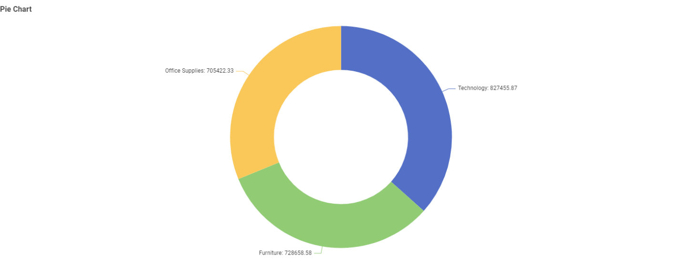
Used to visualize the percentage contribution of each Category to the total Sales. This chart helped identify which product category generates the highest revenue.

Bar Chart – Sub-Category vs Total Sale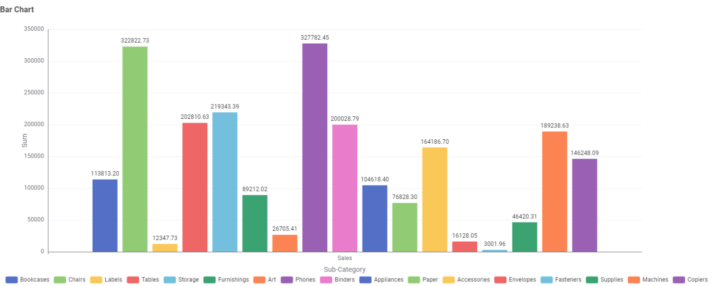
A bar chart was generated to compare total sales across all product sub-categories.
This visualization highlighted the top-performing sub-categories in terms of revenue.

Scatter Plot – Order ID vs Sales
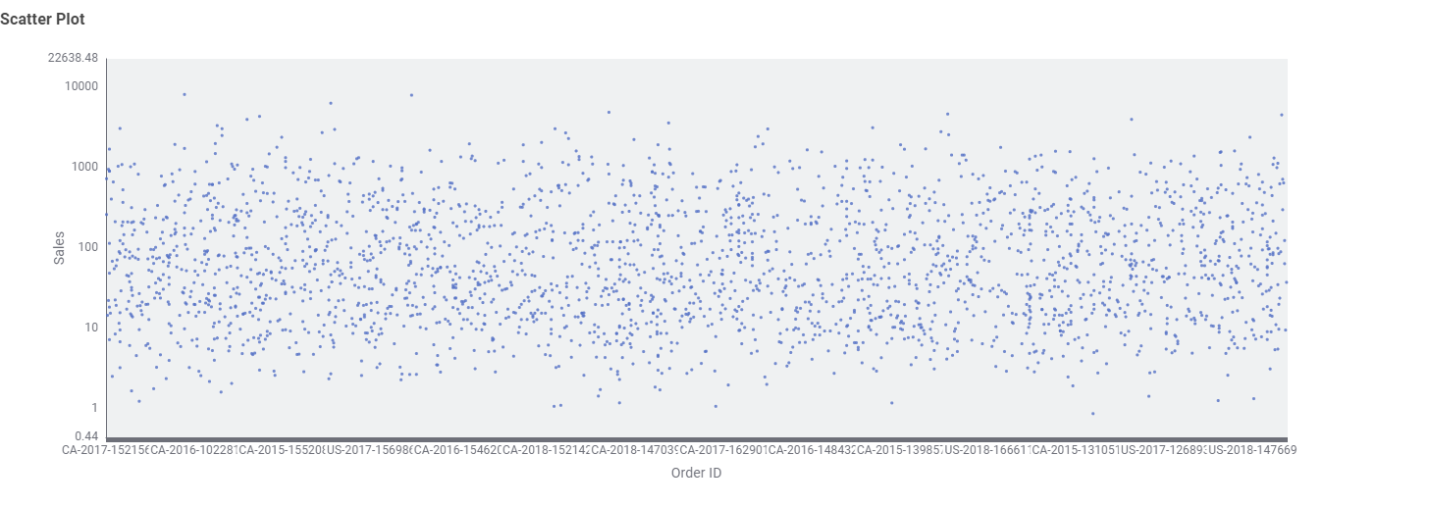
This plot showed the relationship between Order ID and Sales.
It helped identify the range of sales per order and detect any outliers or unusual sales behavior.
Histogram – Sales Distribution

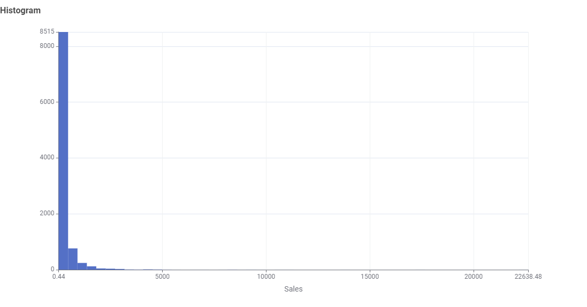
The histogram displayed how sales values are distributed across the dataset.
It revealed the skewness of the sales data and showed that most transactions fall within lower sales ranges.
Heatmap – Category vs Region

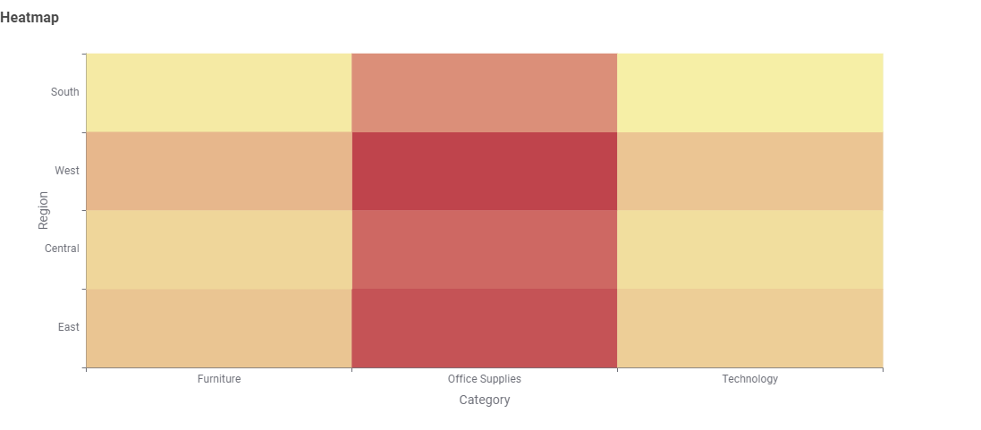
A heatmap was used to visualize cross-tabulated intensity between Category and Region.
It showed which regions purchase specific product categories more frequently.
Density Plot – Sales vs Segment

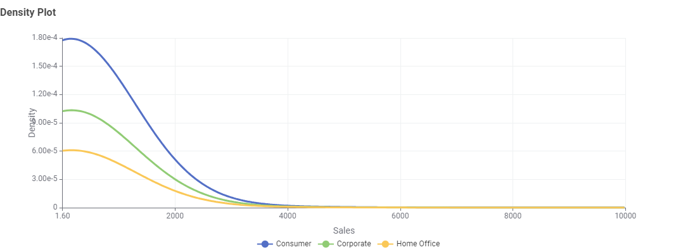
The density plot illustrated how sales values are distributed across customer segments.
It helped detect which segment tends to generate higher sales levels.

2. Machine Learning Models Used
Two regression models were built in KNIME to predict the numerical target variable (Sales).
Both models used the same set of input features:
Features used:
Ship Mode, Segment, Country, State, Region, Category, Sub-Category

Model 1: Linear Regression
- A simple and interpretable regression algorithm
- Assumes a linear relationship between input features and the target (Sales)
- Works as a good baseline model
- Fast to train but limited in capturing complex, non-linear relationships
- Encodes categorical features automatically through KNIME preprocessing.

Model 2: Random Forest Regression
- An ensemble learning algorithm built using multiple decision trees
- Capable of capturing non-linear patterns in the data
- More robust against noise compared to linear regression
- Handles categorical and continuous variables effectively
- Typically provides higher predictive performance for complex datasets

3.Model Evaluation and Metrics
Both models were evaluated using the Numeric Scorer node in KNIME.
The following metrics were generated:

Linear Regression Evaluation
Metric | Value
R² | -2.811
MAE (Mean Absolute Error) | 4,750.428
MSE (Mean Squared Error) | 30,527,031.349
RMSE | 5,525.127
MAPE | 1.264%
Interpretation:
- Negative R² means the model performs worse than predicting the mean.
- High MSE and RMSE indicate the model is not fitting the data well.
- Linear Regression is unable to capture the complexity in Sales.
Random Forest Regression Evaluation
Metric | Value
R² | -2.883
MAE | 4,799.437
MSE | 31,109,078.504
RMSE | 5,577.551
MAPE | 1.262%
Interpretation:
- R² is also negative → struggle to generalize with this feature set.
- Errors (MAE, RMSE) are similar to Linear Regression.
- Slightly worse R² and error values.

4. Comparison & Best Model
Linear Regression
Pros:
- Simple and Fast
- interpretable
Cons:
- Cannot model categorical complexity well
- Performs poorly with non-linear relationships
- Negative R² → weak performance

Random Forest Regression
Pros:
- Captures non-linearity
- More robust
- Handles categorical variables better
- More stable predictions
Cons:
- Still weak performance due to dataset nature and categorical inputs
- Slightly worse R² than Linear Regression

Conclusion: Which Model Performed Better?
Linear Regression performed slightly better overall
because:
- It had a less negative R² (-2.811 vs -2.883)
- It had slightly lower prediction error values
- Random Forest could not capture enough useful patterns from categorical features
Final Selected Model:
Linear Regression (as the better performing model)

